**Business process research**

Student: Jorn Kersten

Student number: 483331

Date: 06-01-2023

Semester: S-DB-IPS3-S3-DB03

Table of contents

What is a Business process 3

Types of business processes: 3

Core process 3

Support process 3

Management process 4

Business process examples 4

What do business processes have to do with software engineering 4

Business process cycle 5

Design 5

Model 6

Execute 6

Monitor 6

Optimize 6

My business process 6

Sources 7

# What is a Business process

A business process is a series of steps or tasks that are required to complete a specific business function. These processes are designed to improve efficiency, reduce waste, and increase profitability. Business processes can be found in every organization, from small businesses to large corporations.

There are many different types of business processes, including operational processes, support processes, and managerial processes. Operational processes are those that directly contribute to the creation of a product or service. These processes may include manufacturing, distribution, and sales. Support processes, on the other hand, provide indirect support to the organization's operations. These processes may include finance, human resources, and IT. Managerial processes are responsible for the planning, organizing, and controlling of the organization's resources.

## Types of business processes:

### Core process

Core processes are the primary business processes that are essential to an organization's operations and success. These processes are directly related to the organization's mission and are central to the delivery of its products or services.

Core processes can be found in every organization, regardless of size or industry. Examples of core processes may include manufacturing, product development, customer service, and marketing. These processes are typically responsible for generating the majority of the organization's revenue and are considered to be the most important processes within the organization.

Improving core processes is often a top priority for organizations, as these processes play a significant role in the organization's overall performance and competitiveness. By streamlining and optimizing core processes, organizations can improve efficiency, reduce costs, and increase profitability.

### Support process

Support processes are business processes that provide indirect support to an organization's operations. These processes are not directly involved in the creation of a product or service, but rather support the organization's operations in some way. Examples of support processes may include finance, human resources, and IT.

Support processes are often referred to as "back-office" processes, as they do not directly interact with customers. While these processes may not be as visible as operational processes, they are still important for the overall functioning and success of the organization.

Effective support processes are crucial for the smooth operation of an organization. For example, a well-managed finance process can ensure that the organization has the necessary financial resources to support its operations, while a well-managed human resources process can attract and retain top talent.

### Management process

Managerial processes are business processes that are responsible for the planning, organizing, and controlling of an organization's resources. These processes are typically carried out by managers and are focused on ensuring that the organization is able to achieve its goals and objectives.

Examples of managerial processes may include strategic planning, budgeting, and performance management. These processes help to ensure that the organization is aligned with its long-term goals and that resources are being used effectively to support these goals.

# Business process examples

In the example below, you can see a business process about selling a product, this is a Core process. The process starts with an order from a customer, then the web shop checks whether there is enough of that product in stock. If there is insufficient stock, the web shop sends a request to the customer to change the order. If there is enough stock, the order is packed and then sent to the customer. After this, the process ends.

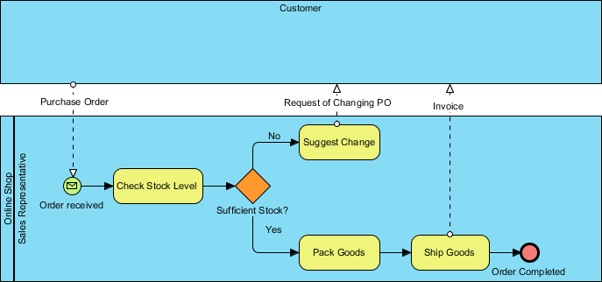

# What do business processes have to do with software engineering

A business process can be used for a number of things within software engineering. A business process can be used to write down a stakeholder's current process and also look at how it could be done better. A business process can also be created for the creation and eventual release of a website.

# Business process cycle

The business process lifecycle refers to the series of steps or phases that are followed when designing, implementing, and improving business processes. The exact steps or phases of the business process lifecycle may vary depending on the approach or methodology being used, but generally, the lifecycle includes the following phases:

1. Design
2. Model
3. Execute
4. Monitor
5. Optimize

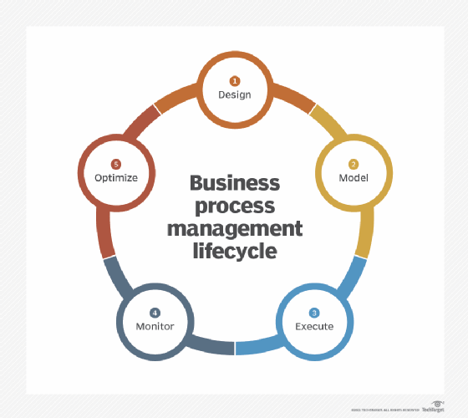

## Design

The process identification and design stage of the business process lifecycle involves identifying and defining a business process. This stage is typically focused on understanding the current state of the process and identifying opportunities for improvement.

During the process identification and design stage, it is important to understand the inputs and outputs of the process, as well as the process steps and responsibilities. This may involve gathering input from stakeholders and subject matter experts, and creating process flowcharts to visualize the process.

## Model

Modelling and analysis is the practice of visualizing and analysing a business process to better understand how it works and identify potential improvements. Process modelling involves creating a representation of the process, such as a flowchart, which can help to clarify the process steps and responsibilities.

## Execute

Execute is the stage of the business process lifecycle in which a new or modified business process is put into practice. The execute stage is typically focused on ensuring that the process is correctly implemented and that all stakeholders are trained and prepared to use the new process.

## Monitor

Monitoring involves gathering data on the performance of a business process and analysing this data to identify trends and areas for improvement. This can be done using a variety of tools and techniques, such as process mapping, process modelling, and process performance metrics.

## Optimize

Optimization involves implementing changes to a business process to improve its efficiency and effectiveness. This may include streamlining steps in the process, automating tasks, or reallocating resources.

# My business process

I created a business process for the group project together with Nick about starting the web scraper. The purpose of the process is to map out the flow of what a user has to do to start the web scraper. We also included the process of the web scraper.

It starts with the user navigating to the admin page of wjjcn. This is where the user logs in. Then the user presses the "Start scraper" button, this sends an action to the back-end where the script is called. There, the steps of the scraper are then executed.

It starts by retrieving which retailers are to be scrapped, then the URLs of the retailer's website are retrieved. Here the links of all products are then filtered out and finally the data from this is compared and uploaded to the database.

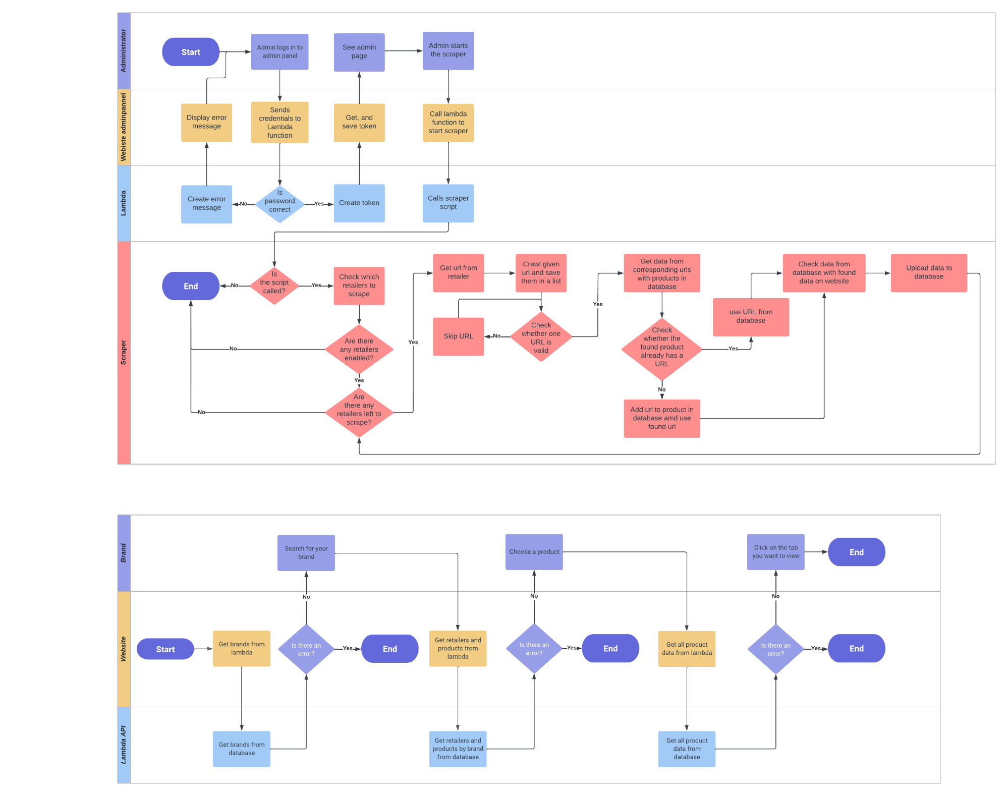

[Full image](https://raw.githubusercontent.com/WJJCN/Documentation/main/Documentatie/Afbeeldingen/WoC%20-%20Business%20process%20diagram%20scraper.png)

# Sources

<https://kissflow.com/workflow/bpm/business-process/>

<https://www.gbtec.com/resources/bpm-business-process-management/>

<https://www.visual-paradigm.com/tutorials/as-is-to-be-business-process.jsp>